(A 10pt line space)

Title of the Paper [Times New Roman, Size 14, Bold]
(A 10pt line space)
Tanvir Ahmed Choudhury^{1,*} and Md. Shariful I. Khan² [Times New Roman, size 12, Italic]
¹Department of Mechanical Engineering, Khulna University of Engineering & Technology, Khulna-9203, Bangladesh
²Department of Mechanical Engineering, Federal University of Technology, Ontario, Canada [Times New Roman, size10]
(After affiliation: Two lines space with 10pt) [Name and affiliation should be included only in the camera ready paper]

ABSTRACT
The abstract should be placed here. Do not Modify Header and Footer.
(After abstract: A 10pt line space)
Keywords: Three to Five keywords ([Times New Roman, size10, centered]; Comma Separated and Capitalize Each Word).
(After keyword: A 10pt line space)
 | Copyright @ All authors  This work is licensed under a Creative Commons Attribution 4.0 International License.
(A 10pt line space)

1. Introduction
Papers must be prepared according the guidelines given in this template. This MS-Word document can also be used as a template. Prepare the article with the paper size A4, i.e., 210 mm by 297 mm. The top margin is 22 mm, and the left, right, and bottom margins are of 15 mm. The main text should be written in two-column format with a font of 10pt Times New Roman. The spacings between columns should be 10 mm.
(Before heading: A 10pt line space)

2. Components
Main text, headings, equations, figures, and tables should be formatted as follows:
(Before heading: A 10pt line space)

2.1 Main Text
All body texts/paragraphs of the main text (Indentation: First line indentation = 5 mm; justified; 10 pt Time New Roman; spacing “single”.
(Before heading: A 10pt line space)

2.2 Headings
Top headings should be in bold. Size: 10 pt Times New Roman. Please check the headings of this template as reference. Please try to keep a maximum 3 levels of headings. Each word of the headings should be title case i.e., capitalize each word. Third level heading should be italic as shown below.
(Before heading: A 10pt line space)

Heading 3
(A 10pt line space)

2.3 Equations
Equations and symbols:10 pt italic font except super/sub scripts. There should be one line space above and below the equation. In the main text, an equation is cited as Eq. (1).
(A 10pt line space)
$\frac{∂a}{∂x}+\frac{∂t}{∂y}=0$ (1)
(A 10pt line space)

2.4 Figures and Tables
Keep table cell margins 0.5 mm. Figures and tables should be cited in text as “Fig. 1” and “Table 1” respectively. Double column figure width: 85 mm (see Fig. 1). Single column figure and table width: 175 mm (see Fig. 2 and Table 2). Font size of the figures and tables should be 10 pt Times New Roman and should match with the body text. An example table is given in Table 1. Table header row texts should be bold; top and bottom borders of table header row and table should be visible. A 10 pt line space above and below the tables and figures. A 10 pt line space after figure captions should be given. Table and figures should be cited before their first appearance in the main text. Table captions should be left aligned and figure captions should be centered.
(A 10pt line space)
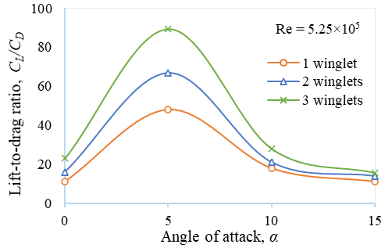
(A 10pt line space)
Fig. 1 Lift to drag ratio vs angle of attack.
(A 10pt line space)
Table 1 Test results.
(A 10pt line space)
Sample name | Fastness |  | Fastness
Sample name | Leather | Fabrics | Leather | Fabrics
Sample 1 | 5 | 5 | 5 | 5
Sample 2 | 5 | 5 | 5 | 5
Sample 3 | 5 | 5 | 5 | 5
Sample 4 | 5 | 5 | 5 | 5
Sample 5 | 5 | 5 | 5 | 5
Sample 6 | 5 | 5 | 5 | 5
(A 10pt line space)

3. Experimental setup/Numerical Modeling
This work has been conducted using a ....
(A 10pt line space)

3.1 Modeling
(A 10pt line space)

Sensitivity
Sensitivity was measured using ...
(A 10pt line space)

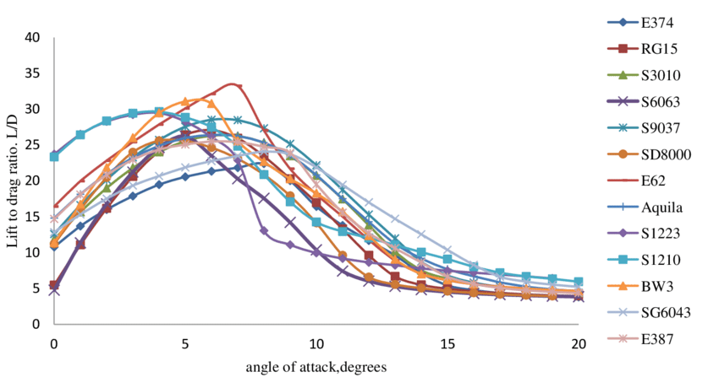
(A 10pt line space)
Fig. 2 Lift to drag ratio vs angle of attack.
(A 10pt line space)
Table 2 Model Performance.
(A 10pt line space)
Model | MAE | MSE | RMSE | MAPE
XGBoost | 14.06 | 283.3 | 16.83 | 21.20%
ARIMA | 13.06 | 262.38 | 16.2 | 21.14%
LSTM | 67.32 | 4536.84 | 67.36 | 21.50%
Prophet | 15.33 | 325.69 | 18.05 | 26.05%
(A 10pt line space)

4. References
References should be cited in the text in square brackets, i.e., [1], [2, 5], [4-7]. The sequence of the references at the end of the reference list should be as their first appearances in the paper. All the cited literature must be listed at the end of manuscript. Use Harvard citation style in the google scholar. Avoid putting the DOI in the list of references.
(A 10pt line space)
- Das, S., Khan, M.A.R., Dash, S.K., Sayeed, E.H. and Talukder, M.M.M., 2025. A Numerical Analysis of NACA 0015 Airfoil with Different Types of Flaps. Journal of Engineering Advancements, 6(03), pp.75-85.
- Mondal, J. and Afsar, S.A., 2025, November. Analysis of Nuclear Reactor Parameters in the VVER-1200 during a Loss of Coolant Accident and Steam Generator Tube Rupture with Emergency Core Cooling System Failure. In SciEn Conference Series: Engineering (Vol. 3, pp. 1-6).
- http://www.abcde.com/fghij/klmn/op123 (Date of access: 12 December 2025).

